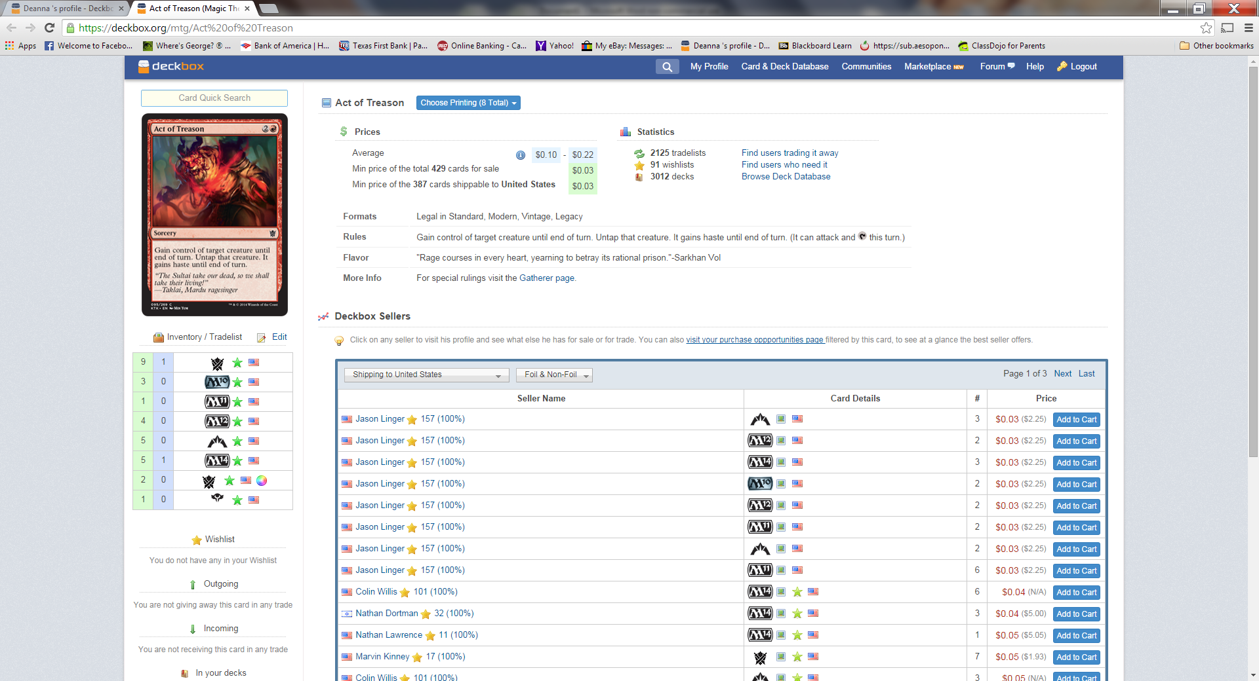
This area use to show the values of each of my variations of cards. Now it just shows the average price of the “whole” card along the top.

My suggestion would be to put the “Inventory/Tradelist” to the right of the Card Picture. Put the prices back with the card variations. If you wanted an “average” on the screen – that’s fine. Make the “Deckbox Sellers” area smaller (it definitely does not need to be that wide) and place the “Prices, Statistics, Formats, Rules, Flavor, More Info” section along the left hand side of the “Deckbox Sellers” area where the “Inventory/Tradelist” currently is. That would make the screen feel a bit like the old one but still have all your new info on it. I wouldn’t have to scroll downward to add to my inventory list that way either. Having the prices per variation was a meaningful tool to have. Please see what you can do to put that back the way it was.

