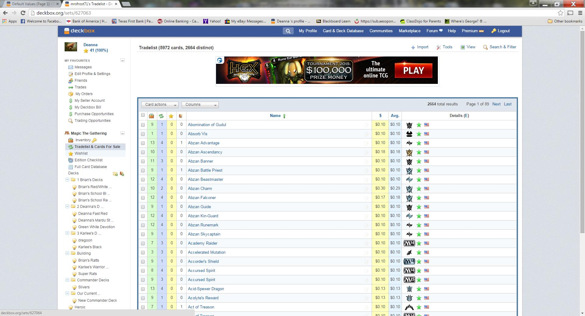
Click Tradelist & Cards For Sale

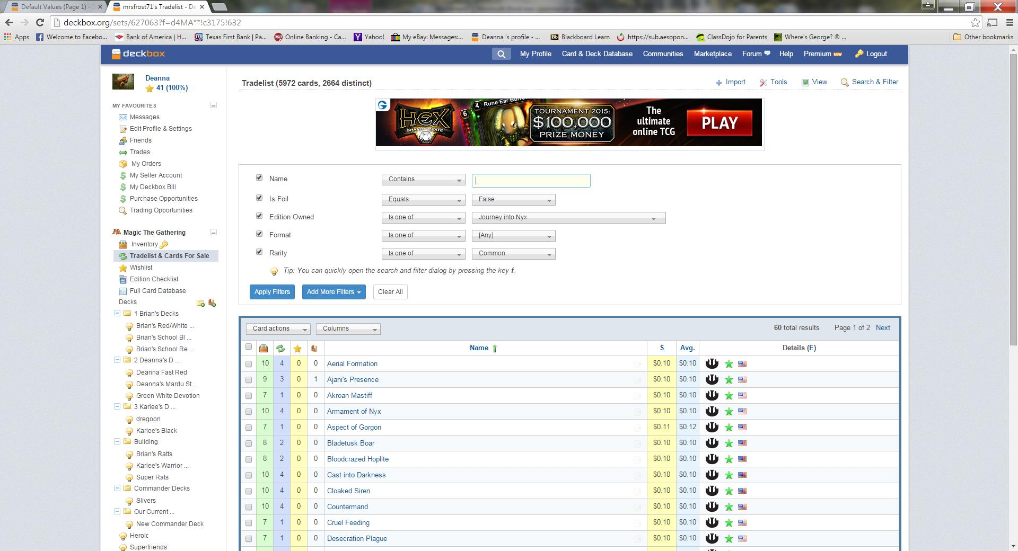
Apply appropriate Filters:
Edition Owned: Journey
Is Foil: False (glad this is working now)
Rarity: Common
Apply Filter – now the list of cards I want to add appear on the screen

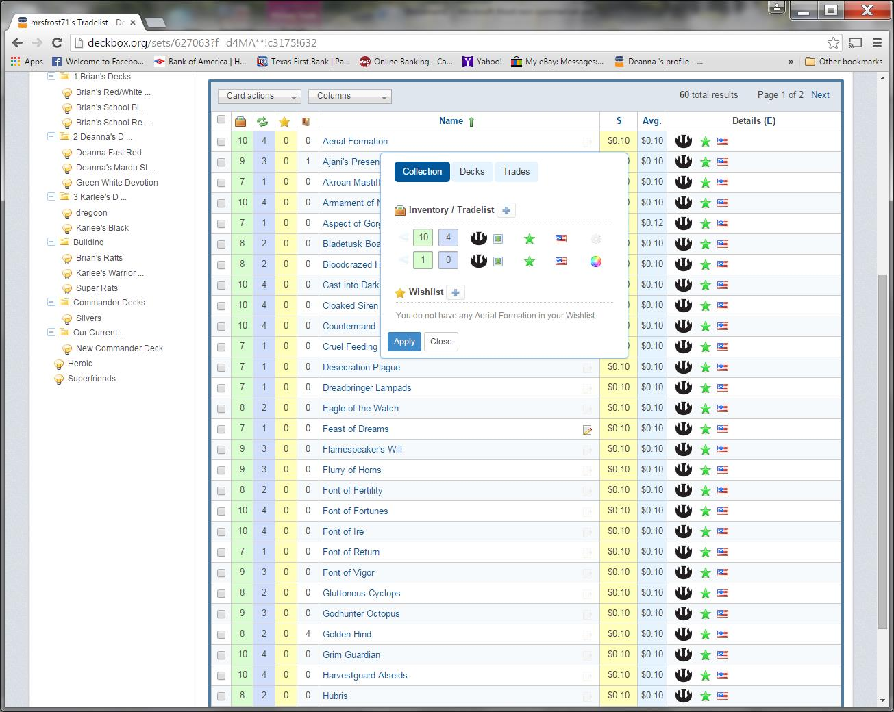
First Card I want to add is Aerial Formation – so I click the Yellow Square that brings me up the shown box.

I click on the “+” sign in that box - - (this is where things have gotten different) – it use to bring up and entry in the same box with an “Inventory” = 1 and “Tradelist” = 1 and my defaults set. (Mint, English) Then I would just hit “Apply” and it would add that card to my existing Inventory/Tradelist
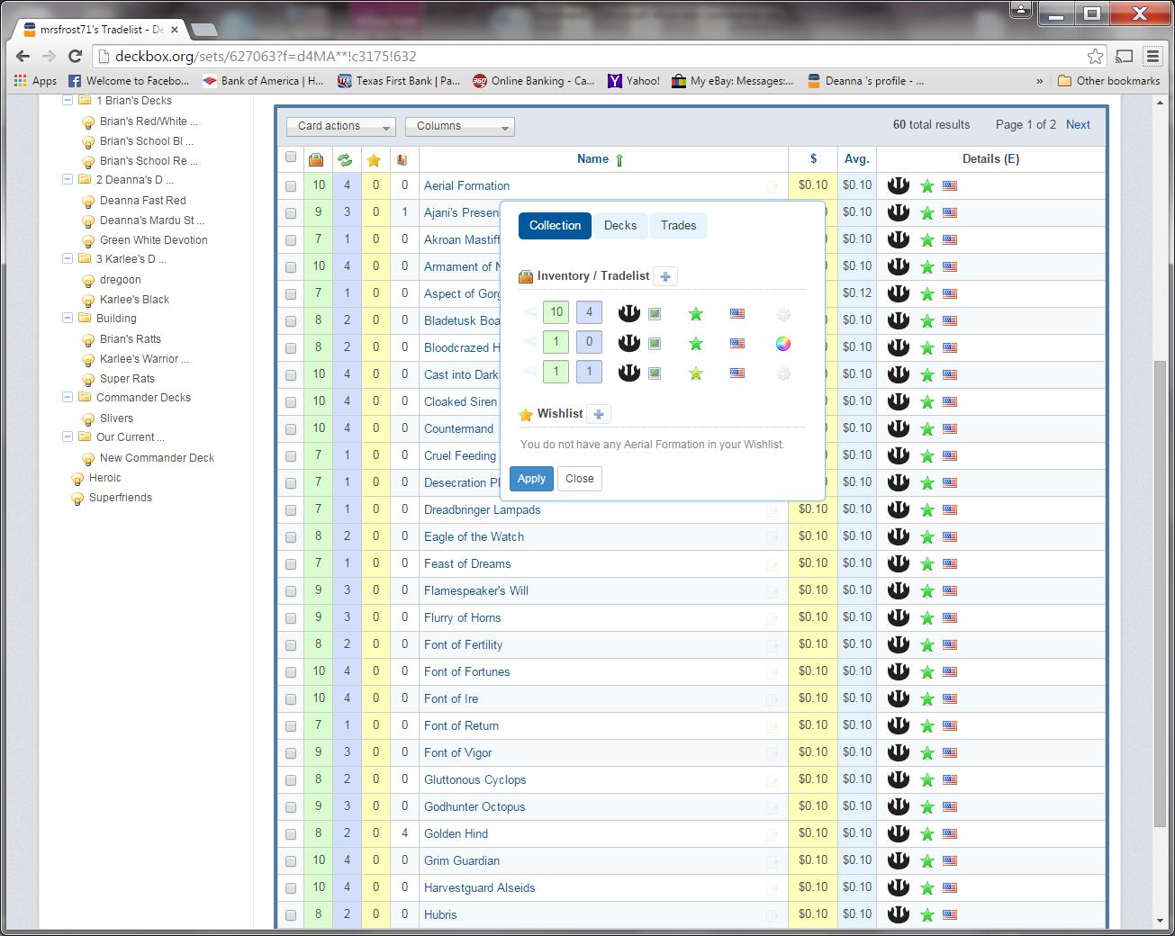
Notice only 1 entry for Aerial Formation
Now when I hit the “+” – I still get my “Inventory” = 1 and my “Tradelist” = 1 but as you can see my Default Value is set to NEAR-MINT and because of this – it will NOT add to my existing Inventory/Tradelist

I hit “Apply” without changing
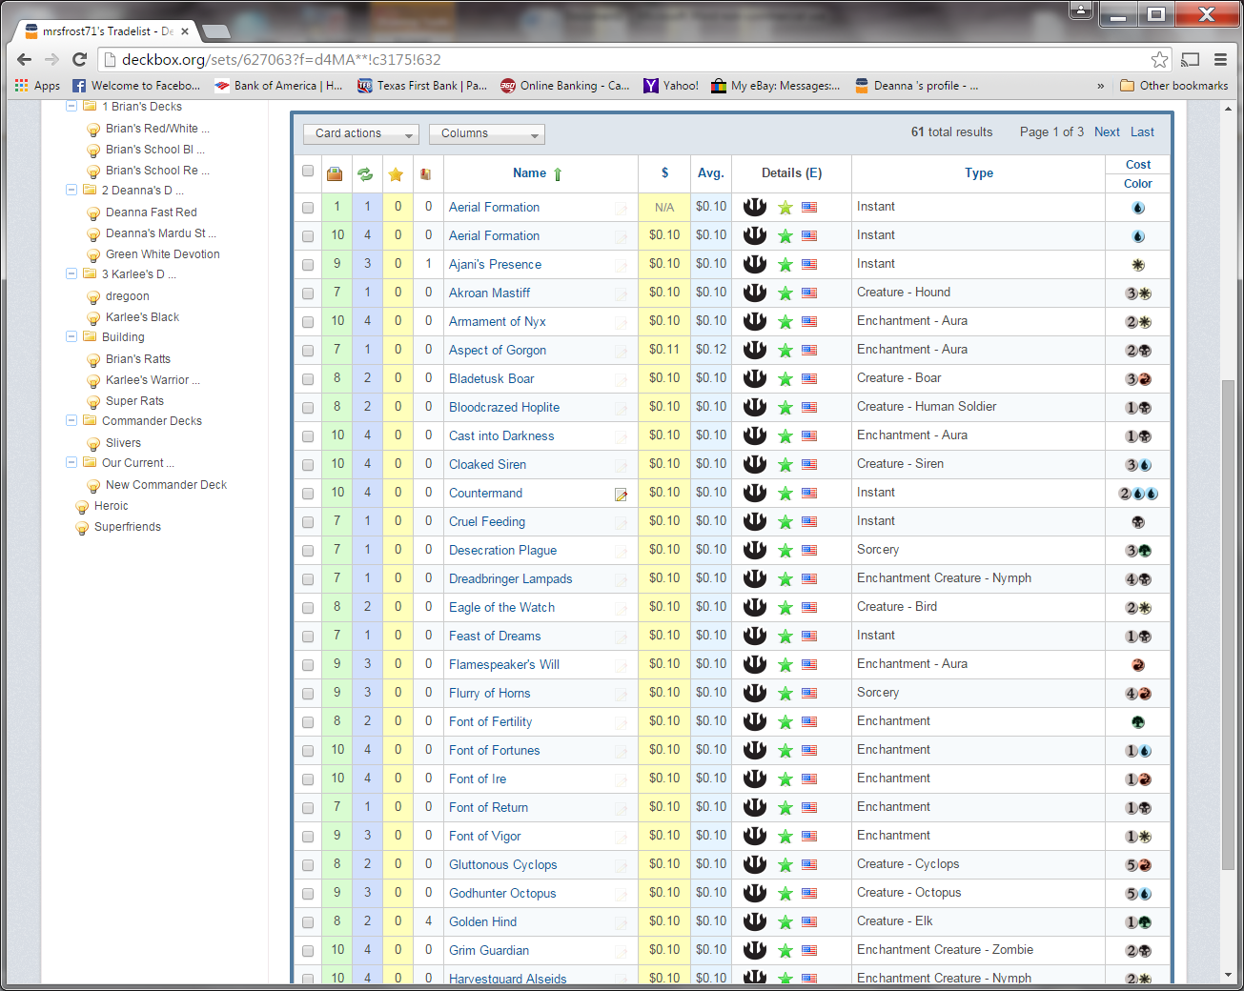
I now have 2 non-matching entries for Aerial Formation – 1 Mint and 1 Near Mint. We use to be able to set those Default Values – and now I can’t find them anywhere!

